Introduction to Full Stack Development & Web Architecture (MERN Overview)

1. Client (Browser)
- This is the application the user interacts with directly.
- Examples include Google Chrome, Mozilla Firefox, or Microsoft Edge.
- Displays the website or app interface
- Sends requests to the server (e.g., when you click a button or submit a form)
- Receives and renders responses (HTML, CSS, JavaScript)

2. Frontend (UI Layer)
- This is the part of the system that runs in the browser and controls what the user sees and interacts with.
- Built using technologies like HTML, CSS, and JavaScript
- Handles layout, design, and user interactions (buttons, forms, animations)
- Can use frameworks like React or Vue.js

3. Backend (Server)
- This is the “brain” of the system that processes requests from the frontend.
- Handles business logic (e.g., login validation, calculations)
- Receives requests from the client and sends back responses
- Communicates with the database
- Built using technologies like Node.js, Python, Java, etc.

4. Database (MongoDB – Conceptual)
- This is where data is stored and retrieved.
- Stores user data, app content, records, etc.
- MongoDB is a NoSQL database that stores data in flexible, JSON-like documents
- The backend interacts with the database (not the frontend directly)

Simple Flow (How they work together):
- User clicks something in the browser (Client)
- Frontend sends a request to the Backend
- Backend processes it and may query the Database
- Database returns data to Backend
- Backend sends response to Frontend
- Frontend updates what the user sees

Sample Diagram:
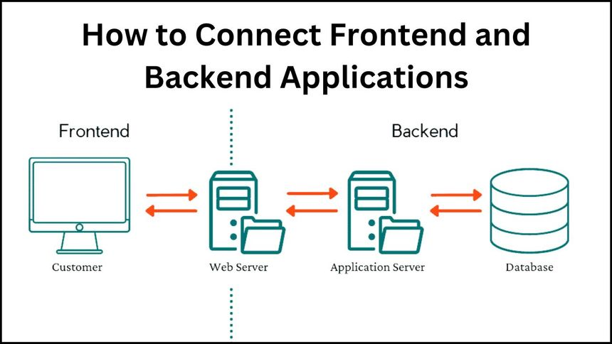

MY PUBLIC GITHUB REPOSITORY:
https://github.com/GravityDefied4/fullstack-intro

